**ASSIGNMENT 10:RISHABH GAUR**

**Q1.** Write a program to print each line of a file in reverse order.

**OUTPUT:-**

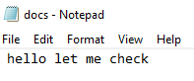

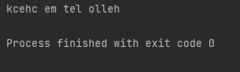

**Q2.** Write a program to compute the number of characters , words and lines in a file.

**OUTPUT:-**

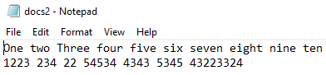

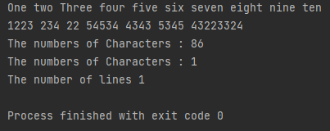

**Q3.** Write a program which takes a list of 10 fruits and writes them to a file .(Make sure fruit names appear on separate lines.)

**OUTPUT:-**

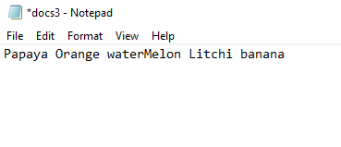

**Q4.** Create a file in notepad which consists of a list of first names of 10 students. Read in the file, sort it into alphabetical order , then write it back to the file.(Make sure file is now in alphabetical order.)

**OUTPUT:- **

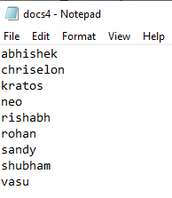

**Q5.** Create a text file of usernames and password(of 7 people.) in the following manner:-

Ram 186abc

Sham 32abzl

Ask the user to enter their user name and password.

The system should read in the details from the file, then return one of the message:_

Your login is successful(correct username and password)

Incorrect password(username exists, password does not match)

Username does not exist(username does not exist in the file)

**OUTPUT:-**

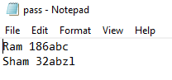

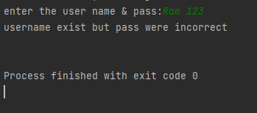

**Q6.** Write a program to read through a file and print the contents of the file, all in upper case.

**OUTPUT:-**

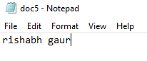

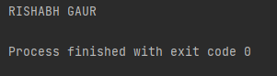

**Q7.** Input 5 random numbers(in range 1 to 500) in file names ‘num.txt’.

**OUTPUT:-**

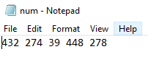

**Q8.** Calculate and display sum of 5 numbers that are stored in ‘num.txt’.

**OUTPUT:-**

